Building Your Personal Website with GitHub Pages

GitHub Pages is a Platform as a Service (PaaS) — specifically a Static Web Hosting PaaS — that allows you to host a static website directly from a GitHub repository. You do not need to manage servers, scaling, or deployment pipelines; everything is handled seamlessly by GitHub. In this project, you will create and publish your own personal website using GitHub Pages.

This project will help you:
1. Learn the fundamentals of web publishing.
2. Gain hands-on experience with GitHub as a version control and hosting platform.
3. Build a professional online presence that can be used as your portfolio, résumé site, or personal blog.

Learning Objectives

By completing this project, you will:
1. Understand what a static website is and how it differs from dynamic websites.
2. Use GitHub Pages as a PaaS solution for hosting static content.
3. Learn how to create, manage, and publish a GitHub repository for web hosting.
4. Customize and design your own personal website using HTML, CSS, and optional templates.
5. Develop professional digital literacy skills relevant to modern software development.

Requirements
1. Create a GitHub account.
2. Set up a new repository named username.github.io, where username is your GitHub username.
3. Add at least a home page to give a brief introduction of yourself.
4. Optional: Customize the layout and style using HTML and CSS by using Jekyll themes or other templates.
5. Publish the website and verify that it is accessible at https://username.github.io.

Deliverables
1. A live, functional website hosted on GitHub Pages.
2. The GitHub repository containing your website’s source code.

Evaluation Criteria
Your project will be graded on the following:
1. Successful deployment on GitHub Pages (website accessible online).
2. Completeness of required home page.
3. Creativity and personalization of design.
4. Correct use of GitHub for version control and publishing.

PROCESS
- CREATE A REPOSITORY
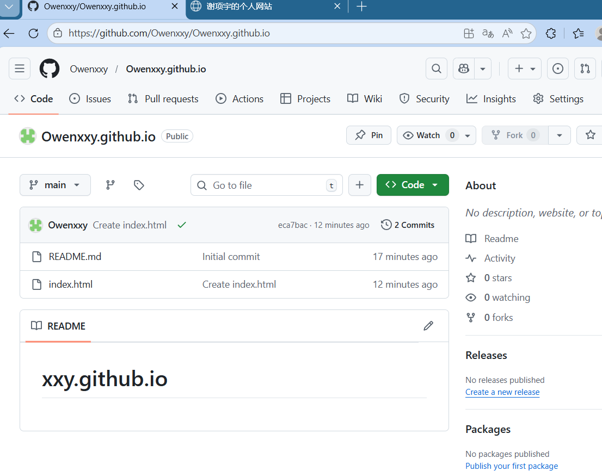
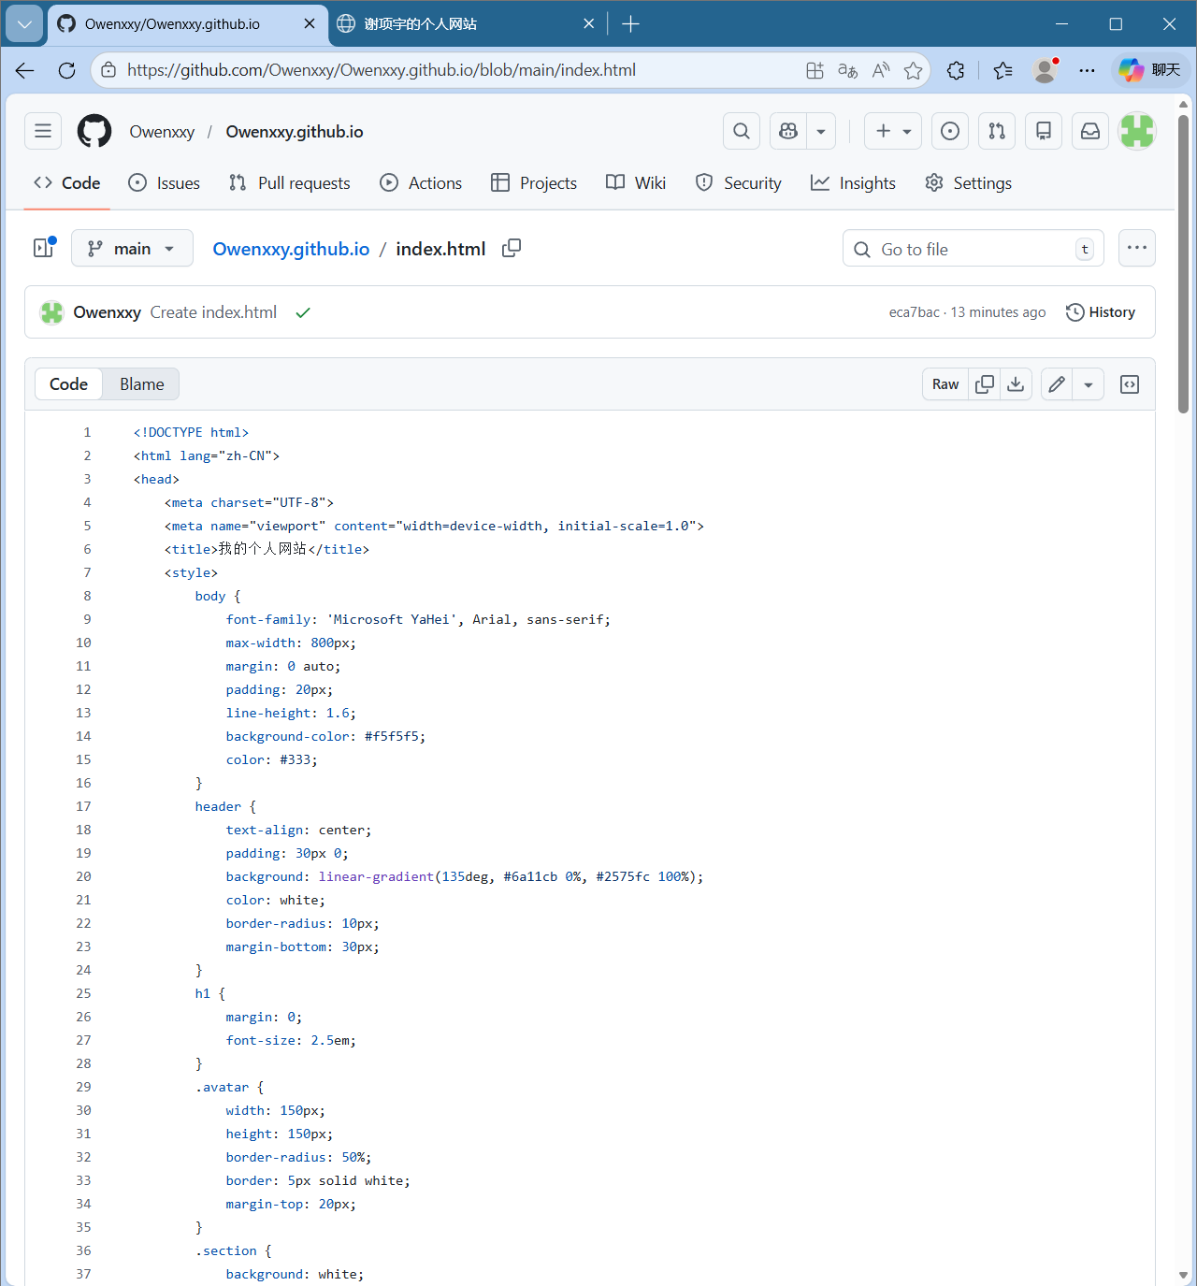
- THE HTML CODE
<!DOCTYPE html>
<html lang="zh-CN">
<head>
<meta charset="UTF-8">
<meta name="viewport" content="width=device-width, initial-scale=1.0">
<title>我的个人网站</title>
<style>
body {
font-family: 'Microsoft YaHei', Arial, sans-serif;
max-width: 800px;
margin: 0 auto;
padding: 20px;
line-height: 1.6;
background-color: #f5f5f5;
color: #333;
}
header {
text-align: center;
padding: 30px 0;
background: linear-gradient(135deg, #6a11cb 0%, #2575fc 100%);
color: white;
border-radius: 10px;
margin-bottom: 30px;
}
h1 {
margin: 0;
font-size: 2.5em;
}
.avatar {
width: 150px;
height: 150px;
border-radius: 50%;
border: 5px solid white;
margin-top: 20px;
}
.section {
background: white;
padding: 25px;
margin-bottom: 25px;
border-radius: 10px;
box-shadow: 0 3px 10px rgba(0,0,0,0.1);
}
h2 {
color: #2575fc;
border-bottom: 2px solid #eee;
padding-bottom: 10px;
}
.skills {
display: flex;
flex-wrap: wrap;
gap: 10px;
}
.skill-tag {
background: #e3f2fd;
padding: 5px 15px;
border-radius: 20px;
font-size: 0.9em;
}
footer {
text-align: center;
margin-top: 40px;
color: #666;
font-size: 0.9em;
}
a {
color: #2575fc;
text-decoration: none;
}
a:hover {
text-decoration: underline;
}
</style>
</head>
<body>
<header>
<h1>欢迎来到我的个人空间</h1>
<p>这是我在 GitHub Pages 上的第一个网站</p>
<!-- 如果要放头像，可以上传图片后替换下面的图片链接 -->
<!-- <img src="avatar.jpg" alt="头像" class="avatar"> -->
</header>

<div class="section">
<h2>👋 关于我</h2>
<p>你好！我是 谢项宇，一名 。</p>
<p>我正在学习网页开发，这是我的第一个用 GitHub Pages 搭建的网站。</p>
<p>我对技术充满热情，喜欢探索新知识和技能。</p>
</div>

<div class="section">
<h2>🎓 教育背景</h2>
<p><strong>南京信息工程大学</strong> - AI</p>
<p>在校时间：2022.9 - 2026.9</p>
<p>主修课程：机器学习，高等数学，网站应用开发</p>
</div>

<div class="section">
<h2>💼 技能</h2>
<div class="skills">
<span class="skill-tag">HTML</span>
<span class="skill-tag">CSS</span>
<span class="skill-tag">Git</span>
<span class="skill-tag">GitHub</span>
<span class="skill-tag">网页设计</span>
<span class="skill-tag">版本控制</span>
<!-- 添加更多技能标签 -->
</div>
</div>

<div class="section">
<h2>📫 联系方式</h2>
<p>邮箱：<a href="mailto:你的邮箱@example.com">215125975@qq.com</a></p>
<p>GitHub：<a href="https://github.com/你的用户名">github.com/你的用户名</a></p>
<!-- 可以添加更多联系方式 -->
</div>

<footer>
<p>© 2023 谢项宇. 本网站使用 GitHub Pages 搭建。</p>
<p>最后更新：<span id="current-date"></span></p>
</footer>

<script>
// 自动显示当前年份
document.getElementById('current-date').textContent = new Date().getFullYear();

// 修改页面标题为你的名字
document.title = "谢项宇的个人网站";

// 简单交互效果：点击标题时提示
document.querySelector('h1').addEventListener('click', function() {
alert('欢迎访问我的网站！');
});
</script>
</body>
</html>

- OUTCOME
